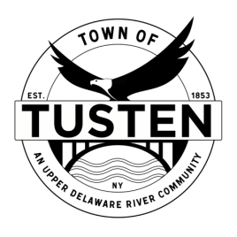
Public Hearing & Regular Meeting Agenda
December 27, 2022
7:25 PM Public Hearing Meeting

Public Hearing @ 7:25 PM
Eagles Nest, 437 Hankins Road, Narrowsburg, NY SBL 23-1-22.5

OPENING ITEMS ~

Call Meeting to Order at 7:30 PM

Pledge of allegiance

Minutes
- Accept Minutes from November 2022
- CORRESPONDENCE

OLD BUSINESS
Eagles Nest Subdivision, 437 Hankins Road
Bobov Yeshiva Educational Center SEQRA Review

NEW BUSINESS
John Gleber, 29 Hankins Road, Narrowsburg NY for lot improvement SBL 23-1-2, 23-1-3.3

Motion to set Public Hearing(s) for (if applicable):

CLOSING ITEMS

Board Comment

Meeting reminder

Adjournment

