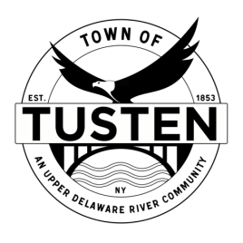
Public Hearing & Regular Meeting Agenda
January 24, 2023
7:15 PM Public Hearing Meeting

Public Hearing @ 7:15 PM
Bobov Yeshiva Educational Center, 189 Blind Pond Road, Narrowsburg, NY SBL ~21-1-5.1, 21-1-1, 21-1-19.1

OPENING ITEMS ~

Call Meeting to Order at 7:30 PM

Pledge of allegiance

Minutes
- Accept Minutes from December 2022
- CORRESPONDENCE

OLD BUSINESS
Bobov Yeshiva Educational Center

NEW BUSINESS

Motion to set Public Hearing(s) for (if applicable):

CLOSING ITEMS

Board Comment

Meeting reminder

Adjournment

