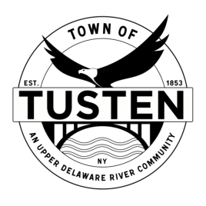
Public Hearing & Regular Meeting Agenda
May 8, 2023
7:20 PM

OPENING ITEMS
Public hearing 7:20 PM ~ John Gleber Application, 23 Hankins Road, Narrowsburg, NY ~ SBL 23-1-2, 23-1-3.3

Call Meeting to Order at 7:30PM

Pledge of allegiance

Minutes
- Accept Minutes from April 2023

OLD BUSINESS
John Gleber Application, 23 Hankins Road, Narrowsburg, NY ~ SBL 23-1-2, 23-1-3.3

NEW BUSINESS
Building Permit Appeal from Weidens concerning 174 Bridge Street, Narrowsburg

SET PUBLIC HEARING (S) ~ if applicable

Motion to set Public Hearing(s) for:

CLOSING ITEMS

Board Comment

Meeting reminder

Adjournment

