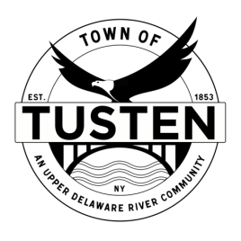
Public Hearings & Regular Meeting Agenda
August 22, 2023

PUBLIC HEARINGS:
~~7: 15 PM Kathryn Andrews, 96 Kirk Road, Narrowsburg special use permit for Dog Wash SBL 8-2-5.2
~~7:20 PM Anthony Marsanico & Janet Sgritto, Lake Shore Road, for subdivision SBL 15-12-2 & 5-1-13.1
~~7:25 PM Steve Miss, 22 Skipperene Road, Narrowsburg NY for special use permit SBL 1-1-21.6

OPENING ITEMS ~

Call Meeting to Order at 7:30 PM

Pledge of allegiance

Minutes
- Accept Minutes from July 2023
- CORRESPONDENCE

OLD BUSINESS

NEW BUSINESS

Motion to set Public Hearing(s) for (if applicable):

CLOSING ITEMS

Board Comment

Meeting reminder

Adjournment

