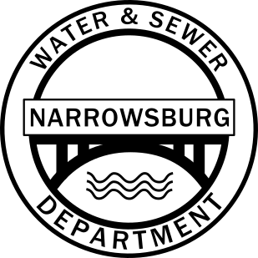 | Narrowsburg Water & Sewer District  210 Bridge Street  Narrowsburg, NY 12764  (845) 252 7376  nws@tusten.org

Sand Filter Bid for 2022
Instructions to Bidders:
The Town of Tusten will accept bids on the form provided for filter sand at 210 Bridge St., Narrowsburg NY 12764. Bids will be accepted by the Town Clerk until October 10th, 2022 at noon.
General Specifications:
- Media shall consist of washed natural sand consisting of hard, strong, durable particles which are free from clay, dust, organic matter, coating or deleterious substance.
- The effective grain size shall range from 0.40 to 1.00 mm, with a uniformity coefficient less than 4.
- The contractor shall provide and/or deliver for the proposed price of 500 cubic yards of sand, meeting these specifications to the Narrowsburg Sewer Treatment Plant.
- Sand shall be delivered in dump trucks only.
Award:
- Bids must be submitted on the attached bid form.
- A non-collusion bidding certificate must be submitted with each bid, copy attached.
- Award of the bid shall be made under the direction of the Town Board on October 11th, 2022 at the regular board meeting which starts at 6:30PM.
- In cases where two or more responsible bidders submit identical bids as to price, the contract may be awarded to either of such bidders.
- The award shall be made on the most advantageous bid, on the quality verses price basis, taking into consideration the responsibility of the bidder and materials or terms deemed to be best adapted to the uses of the Town of Tusten.
- The Town of Tusten or Departments awarding the bids reserve the right to accept or reject any bid which it deems is in the best interest to the Town of Tusten.
Taxes:
Purchases by the Town of Tusten for its use are not subject to any sales, use, or federal excise taxes and exemption certifications will be executed upon request and payment.
Filter Sand Testing:
As part of the proposal the bidder shall submit a certified copy of lab tests and gradation curves indicating the material meets the effective size and uniformity coefficient specifications.
After the Town Board identifies a low bidder/supplier the contractor shall create a 500 cubic yard stockpile of material intended to be delivered to the Narrowsburg Sewer Treatment Plant. The town will then sample the material stockpiled, test the samples for specifications compliance prior to delivery to the Sewer Treatment Plant site and accept or reject the entire stockpile.
Any further information may be obtained from the Narrowsburg Sewer District Superintendent; 210 Bridge St, Narrowsburg, NY 12764 (845) 252-7376.

Town Of Tusten
Non-Collusion Bidding Certification

The following statement is hereby made by the undersigned to accompany the sealed bid by the undersigned.
The undersigned hereby certifies:
.1 That the bid which is accompanied by this statement has been arrived at without collusion with any seller of the same materials, and
.2 That the contents of the bid have not been communicated by the bidder to one of its agents to any persons outside the company.

Dated:

Name of Company:

Address:

By:

Title:
Bid Form

Date:

Name of Company:

Contact/Title:

Address:

Phone:

Price of 500 cubic yards of sand
meeting bid specifications:

Price of 500 cubic yards of sand
meeting bid specifications and
delivered to filter bed site:

